For more information please contact:
Learning Estates Team
Education & Children’s Services
Gordon House
Blackhall Road
Inverurie
AB51 3WA
rezoning@aberdeenshire.gov.uk
01467 628442

Midmill School
Admissions
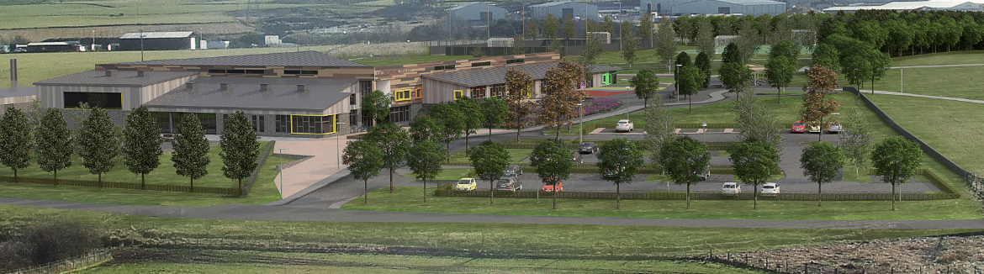
Artist impression of the new Midmill School
Address:
Midmill School
Carnie Brae
Kintore
Midmill School Background information
In 2013, Aberdeenshire Council approved a proposal for additional primary education provision with a delivery of a new school in Kintore after substantial community engagement.

In May 2015 the Education, Learning and Leisure Committee approved a new catchment area and the name of the new school was decided as “Midmill School”.

The new school will be built in the Midmill area of Kintore with a capacity of 540 pupils and will open during the 2016/2017 session and pupils will be able to attend from that point.

New primary 1 pupils and those moving into the new catchment area will attend Midmill School. Please refer to the map for the catchment area of Midmill School.

It is important to know that there are no plans to move existing pupils from Kintore School to the new school but pupils do have the option to move if they so wish and will be required to fill out the admission form.

Midmill School Catchment Map
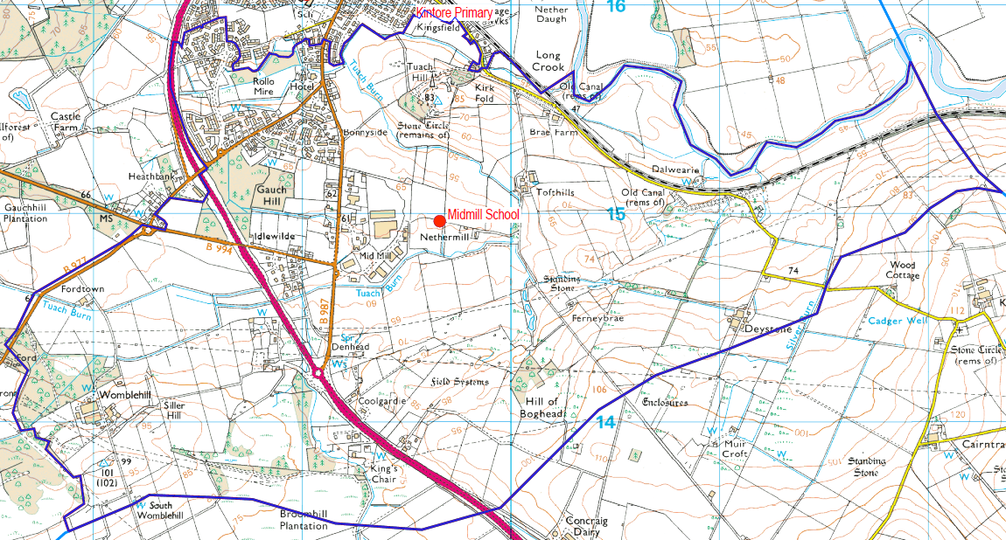

Admissions Period 23 Nov – 11 Dec 2015

This is for all P1 pupils due to attend the new school and all other pupils in zone for the Midmill school who wish to attend.

If you would like to apply to attend Midmill School please fill in an admission form and send back to us by Friday 11th December 2015.

If you need another form, these are available from:

- Kintore School
- Kintore Library
- Aberdeenshire Council, Education and Children’s Services, Gordon House, Blackhall Road, Inverurie, AB51 3WA
- Forms can also be sent out by email, please contact rezoning@aberdeenshire.gov.uk or telephone 01467 628442.

Forms B, D, E and F can be collected from your local school.

Children who are not currently in a school or school nursery will be contacted in January 2016 to arrange submission of proof of identification documents.

Nursery admissions for Midmill School will take place at the same time as the normal pre-school admission periods for all school nurseries across Aberdeenshire.

Please return the completed forms to Learning Estates, Education & Children’s Services, Gordon House, Blackhall Road, Inverurie, AB51 3WA.

Email:rezoning@aberdeenshire.gov.uk

