Educational Psychology Service Self-Evaluation
Head Teacher (Primary Schools) Survey March 2015
A service evaluation form was sent to 150 Primary School Head Teachers across Aberdeenshire in March 2015. The aim of the survey was to gain Head Teacher’s views about the service provided by the Aberdeenshire Educational Psychology Service (EPS).
Of the 150 Head Teachers surveyed, 73 respondents returned completed questionnaires (49% response rate).
Feedback was obtained around 3 key questions:
- How satisfied were you with the work of the Educational Psychology Service (EPS)?
- What do you appreciate the most about the work of the EPS?
- What one improvement would you most welcome?

Q1. How satisfied were you with the work of the EPS?
Overall, the satisfaction rate for the entire Service was very positive:
- 59 respondents were either completely satisfied or satisfied (almost 81%)
- 9 respondents were neither satisfied nor dissatisfied (12%)
- 4 respondents were dissatisfied (almost 6%)
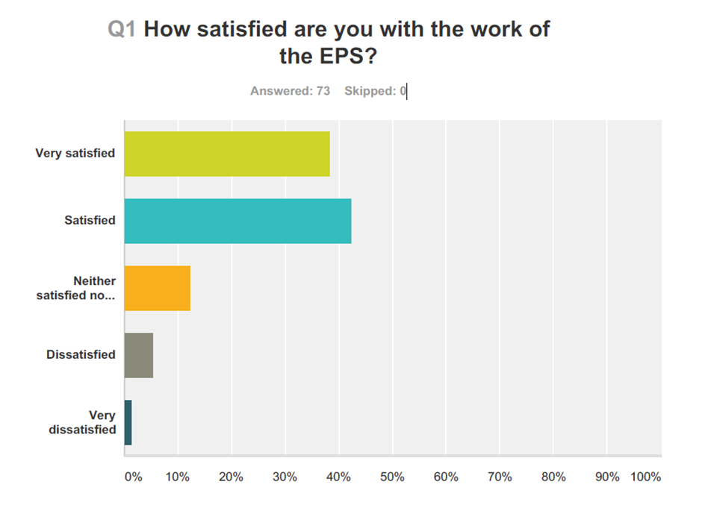
- 1 respondent was very dissatisfied (1%)
Figure 1:
Figure 1:

Q2. What do you appreciate the most about the work of the EPS?
Figure 2: Areas of appreciation

Consultation model of service delivery
General appreciation of the support, advice and expertise provided by the EPs and the reassurance they provide
Sub themes:
- Informal consultation
- Provision of strategies
- Professional dialogue

Training
The training and Continued Professional Development (CPD) opportunities offered by EPS e.g. twilight session on self-regulation
Accessibility
Sub theme:
- Flexibility
- Speed of response
- Consistency
- Pro-active

Intervention and assessment
There was also a gratitude for the support provided by EPS through assessments/observations and direct interventions
Relationship
Strong relationship between EPS and stakeholders resulting in positive collaborative working/ partnerships

Sub theme:
- Support at meetings

Finally, one respondent said they appreciated ‘everything’ the EPS do, while another said ‘All the core functions’

Q3. What one improvement would you most welcome?

Figure 3: What improvements the HTs would most welcome

Time
A general desire for more time with the EPs
More direct stakeholder work
Sub-themes:
- Young People (YP)
- More time spent working with YPs including carrying out more observations & assessment

- Staff
- Extra support delivering recommended interventions and strategies
- Want more tailored advice or next level strategies

Continuity
Desire for continuity of EP staff, although one such respondent did acknowledge that this continuity can be difficult for the service to achieve given other staffing considerations
There was also a need for the consistency of the support provided

Training
More training opportunities e.g. twilight training sessions

Stakeholder Communication
For example stricter guidance on authority-wide initiatives and informing schools if parents have directly contacted the EPS

None/positive
5 respondents said they could not think of any improvements
5 respondents were very happy with service, remarking only positive comments instead of improvement suggestions (e.g. ‘I am thrilled with the support I have received’)

