PETERHEAD DEVELOPMENT PARTNERSHIP

VISION AND ACTION PLAN


Vision 2021
Peterhead is the vibrant economic heart for the Buchan communities & reaches out to the world through its maritime industry, enterprise, ambition, culture & its communities.

Peterhead’s Town Centre has been rediscovered with improved facilities including a diverse quality family friendly shopping/leisure experience & evening economy with interesting cultural events.

The distinct communities in Peterhead work together to celebrate differences with renewed civic confidence & pride of place. This is an independent, energised, committed & supportive community town.

Introduction

The Peterhead Development Partnership Plan is a plan for public, private and third/voluntary sectors and the wider community to help regenerate the town and make strategic changes for its continued development as a regional hub into the 21st century. Transformational change takes time, this plan looks over a five year period to initiate longer term change whilst providing shorter and medium term interventions which will provide momentum and confidence to businesses and the community. The plan requires the intervention of a number of partners, most already providing excellent work and services to the community. As a Development Partnership, we aim to strengthen all when needed and provide the extra impetus to those delivering major change to the community in Peterhead, ensuring we achieve our long term vision.

Formation of the Plan

A number of recent processes have aligned to form the basis of the Action Plan including:

- Peterhead 2026, the locality planning exercise involving Councillors and officers of Aberdeenshire Council
- The Regeneration Strategy review: Developing Excellence in Our Coastal Communities was approved by Infrastructure Services Committee in March 2016 and instructed officers to establish four Development Partnerships and draw up four regeneration plans for the towns of Banff, Macduff, Peterhead and Fraserburgh.
- Peterhead Development Partnership was formed in June, with evidence from the Community Planning Strategic Assessment, the Locality Plan; Peterhead 2026, Census data and the Peterhead Town Centre Action Plan forming the basis of the background and scoping.
- The community has overwhelmingly participated in the community led Choose Peterhead, community action plan, initiative and this input is reflected in the Action Plan with the focus on the town centre.

The Regeneration Action Plan demonstrates a strong fit: with emerging Scottish Government & Aberdeenshire Council policy for example including:

- Scotland’s Economic Strategy (2015) which sets out an overarching framework to achieve a more productive, cohesive and fairer Scotland and prioritises boosting investment and innovation, supporting inclusive growth and maintaining the focus on increasing internationalisation.

- The National Review of Town Centres: SG Action Plan (2013) One Year On (2014) & Town Centre Toolkit (2015). The main focus of the 2013 review was on Community and Enterprise and the Action Plan highlights the ‘Town Centre First Principle’.

- The New Regeneration Strategy for Aberdeenshire (above) with the three key themes of people, places and prosperity. (see Key Outcomes)

Action Plan Themes

This Regeneration Action Plan sits alongside the scoping documents of “Peterhead 2026”, providing the action elements for public, private and community development which have the potential to create greater change and the main themes are:

Local Economy - Peterhead Open to the World

Peterhead packs an economic punch and is the largest settlement in Aberdeenshire. It has connections via industry all across the globe, but these can be further maximised and extended. The connections can reach into all parts of the community and make Peterhead feel and be connected to global opportunities and responding socially to global challenges. Looking outward will become a new norm for Peterhead, securing its place at the forefront of global industries, in particular marine industries. Through the achievements of its pupils and students it will become an even more important maritime hub, recognised as providing technicians, professionals and endless innovation to the world’s energy and marine sector.

Peterhead boasts Aberdeenshire’s biggest port and an impressive cluster of maritime businesses including marine engineering, fishing and food processing and oil and gas service businesses due to its strategic location on the North Sea. The opportunities for expansion are recognised by Peterhead Port Authority who are in the final stages of securing funding for a £49 Million port development, with expanded fish market and further basin deepening, providing infrastructure for the growing fishing fleet and offshore vessels utilising Peterhead services. The Energetica Corridor will provide a focus for addressing opportunities in the sector and will unlock new interest from residents focussing on Peterhead’s place in the global energy market. The sea, its moods and the multiple recreational and educational opportunities offered by a diverse coastline can link up to provide a distinctiveness to the town centre and visitor experience: from the further development of the town centre heritage trail through to maximising the Bullers of Buchan and the Loch of Strathbeg as key regional attractions.

Integrating the Communities

The distinct communities of Peterhead have drifted apart as the settlement has grown although the spirit of communities coming together can still be seen in the Scottish Week celebration. A new focus on bringing distinct groups of people together, celebrating difference and searching for common ground will put a real drive for one shared community to take control of its own destiny. Independent, energised, committed and supportive community groups will determine the future of society in Peterhead which will become one of the most vibrant and meaningful in Aberdeenshire. Housing and tenure is a key element in achieving balance within the settlement. Housing conditions in some parts of the town need to be improved and wider choice of housing will be essential.

Connecting Reinforcing & Rediscovering Peterhead’s Town Centre

The town centre is currently no longer the physical or social centre for the whole community and yet often the distinct, polarised communities aspire to towns other than Peterhead for their leisure experiences. Reinforcing the town centre, providing a quality and diverse shopping and leisure experience, developing the food offering and evening economy through quality cultural experiences will help people to rediscover and bring the centre back into everyone’s lives and enrich their experiences of place. The Business Improvement District will begin to take local control and ownership of improving the town centre experience. The community will lead actions that have come from the very well supported Choose Peterhead process to transform key areas and reinvigorate underused properties. The town centre will be better connected to business opportunities, to the wider community in Buchan and will offer a cultural distinctiveness often absent from “Clone Town Britain”.

Glossary of Acronyms
AC – Aberdeenshire Council | VA – Visit Aberdeenshire
PPA-Peterhead Port Authority | TS – Transport Scotland
EMFF – European Maritime and Fisheries Fund | CPP – Community Planning Partnership
NESCOL - North East Scotland College | SE-Scottish Enterprise
BG – Business Gateway | NHS – National Health Service
PPA – Peterhead Port Authority

Action Theme 1 – Peterhead Economy – Open to the World
Aim |  | Peterhead’s connections via industry are all across the globe and can be further maximised and extended. The benefits can reach into all parts of the community by moving to an increasingly resilient and higher wage economy |  | Outcomes | Peterhead is even more connected to global opportunities, the business base is increasingly diverse with more opportunities for growth and incomes are increased.
Action | Objective |  | Action | Timescale  Impact | Lead | Regen Budget | Leverage/Other | Output Measure  (XX) = Target
1.1 | Improve Educational Attainment & Achievement: Promote in work progression: Individuals to achieve their potential & support a vibrant local economy |  | Partnership actions to improve educational attainment including:  - Enthuse, motivate, educate, support & above all raise attainment & aspirations in Peterhead.  - Create excitement and relevant connections through partnership activities to inspire all students to study & build careers using science, technology, engineering & maths (STEM).  - Raise profile of economic opportunities and international connections for Peterhead graduates.  -use culture and arts to develop the conversation around aspiration  - Promote in work career progression: working with local businesses/employees to empower people to take control of their career by acquiring a set of skills that lead to lifelong successful career planning. | Medium  High | Developing the Young Workforce  Community Planning Partners  SDS/CMS  Peterhead Academy  NESCOL  Local business  BG | £140K | £140K | Nos students reached 568  Nos local businesses involved 5  Nos successfully completing workshops/courses (60)  Nos girls/women in STEM careers (5% uplift)  Higher level skills & achievements
1.2 | Peterhead Learning Campus |  | Review the property requirements, agree the brief/location & progress the decision to provide a new educational campus including new Peterhead Academy. | Short  High | AC | £0k | £63M | New facilities  Improved educational attainment  Individuals obtaining more/better qualifications  Individuals in rewarding/well paid jobs  Increased participation
1.3 | International Maritime Industries  ‘One Stop Shop’: Develop the profile of Peterhead as a great place for maritime industries & promote Town Centre |  | - Raise the profile of the services offered by Peterhead businesses including business opportunities for decommissioning & projects such as Hywind.  -Target support to & strengthen local business supply chains to drive local economic/business growth.  - Targeted business winning effort to attract marine industries to Peterhead.  - Provide the right working conditions, office accommodation and infrastructure to support marine industries supply chain & sub-contractors requirements.  - Strengthen the commitment of existing maritime industry companies to Peterhead, encourage & support plans for expansion/reinvestment.  - Deliver a series of investment briefings for Peterhead town centre & other sector opportunities. | Short/  Medium term  Medium | AC  PPA  Businesses | £90k | £90k | No of briefings/events (4)  Investment (£100k+)  New business (3)  Growing business (7)  Increase turnover  Jobs
1.4 | Harbour Development |  | Peterhead Port Authority to deliver stage 1 of the Port Redevelopment plan – incorporating new fish market, deepening of the inner harbour and opening up of existing fish market for new opportunities. Support PPA to progress towards phase 2 including improved ship repair facilities and potential new Seafood Processing Hub. | Short  High impact | PPA | £40K | £49M | Investment (£100k+)  Growing business  Increased turnover  Jobs
1.5 | Food & Drink: Sector Development |  | - Support the Peterhead element of the Blue Careers Initiative, which focusses on skills & career development  - Investigate new supplier development opportunities to enhance supply chain value & encouraging career & business opportunities in the sector.  - Harbour Seafood Quarter – explore & support potential to up- scale the food service offering linked with an improved town centre cultural sector (see 2.1 & 3.3).  - Access to markets initiative to support local businesses to increase sales. throughout Scotland & the rest of the UK  - Facilitate engagement between the research base/universities.  & the local food and drink sector to deliver opportunities to innovate particularly around nutrition & health.  - Develop linkages with the local tourism sectors to increase economic impact by having a distinctive local food & drink proposition. | Medium  Medium | SDS  AC  Businesses | £75K | £250K | Business Growth (10)  Business Start up (15)  Improved personal development opportunities
1.6 | Energetica: Attracting Inward Investment to Peterhead |  | - Development of Peterhead business facilities & targeted business winning effort to attract inward investment to Peterhead as part of the Energetica: Scotland’s Energy Corridor  -Focus on higher value jobs: e.g renewables, specialist manufacturing, maritime & food /drink.  -Develop a clearly articulated ‘office/work space’ & quality of life inward investment offer for high growth potential sectors, including, renewables, specialist manufacturing & maritime.  - Develop a work / life proposal & specific opportunities for tourism/visitor economy development to include improved profile and promotion of key assets – e.g. Bullers of Buchan, Loch of Strathsbeg.  - Ensure sufficient employment land is available for industrial expansion: review supply & demand.  - Assess and develop proposals for a Simplified Planning Zone to the South and West of Peterhead. | Short/ Medium  Medium | Energetica / partners  VA | £75k | £2M | Inward investment enquiries  Successful projects  Investment (£2m)  New business (4)  Jobs  Simplified Planning Zone agreed.
1.7 | Connectivity and infrastructure |  | Work with NESTRANS, TS, and AC to achieve improvements in transport infrastructure linking the rest of the world to Peterhead. Use the opportunity of the current Aberdeen to Peterhead / Fraserburgh Corridor study to positively influence improvements to the A90, public transport enhancements and advance the very strong case for a rail link to Buchan. | Medium  Medium | AC / TS | £0k | £0k | Investment in road/cycle improvements
1.8 | Develop connections & linkages with international communities |  | - Review Peterhead’s twinning arrangements with Alesund/Norway.  - Aim to reinvigorate twinning with arrangements largely managed by community volunteers so as to broaden cultural, linguistic, social perspectives.  Strengthen ties with North Sea Commission.  - Look to other towns in emerging markets like China & Brazil to explore best practice, learning and market opportunities. | Medium term  Low impact | AC | £10 | £10k  In kind | New cultural, linguistic, social exchanges  Volunteers (10)  Volunteer hours(100)
1.9 | Tourism Product Development |  | Develop the distinctive offering that Peterhead and rural Buchan offers (e.g. Admirality Gateway, Buchan and Formartine Railway) through business collaboration and the development of packaging to link attractions together with other facilities and services.  Consider the potential linkages to other places and product development opportunities based on Peterhead being the most easterly town in Scotland.  Upgrade the museum, building on links to social history, stories of achievement and international connectivity. | Short term  Low impact | Visit Aberdeenshire | £20k | £70k | Increased profile  Increased no of visitors
TOTALS |  |  |  |  |  | £450k | £112.4M  In kind

Action Theme 2 - Integrating Communities – Celebrating Peterhead’s Differences
Objective |  | To bring distinct communities in Peterhead together, celebrating differences, searching for common ground and becoming an even more independent, energised, committed and supportive community. |  | Outcome | Increased community capacity, improving civic pride and a stronger third sector and improved housing choice
Action | Objective |  | Action | Timescale  Impact | Lead | Regen Budget | Leverage/Other | Output Measure
2.1 | Cultural Hub: Celebrate & develop & Peterhead’s cultural offering: Exploring its reach in the world |  | Choose Peterhead identified the community led café; open during the evening, hosting informal language learning opportunities & youth café as a crucial short term priority project. This would be a space where English, Scots / Doric, Polish, Lithuanian, Bulgarian, French, German will all be spoken/learned freely. In the medium/longer term the space could become a cultural hub that delivers the Regeneration Action Plan objectives namely: community integration across different cultures, town centre regeneration & demonstrating international reach.  A business case/feasibility study for the cultural hub will be prepared to:  - Explore the need/demand for the different components.  - Develop a clear brief that confirms specific activities & space requirements.  - Assesses community, stakeholder & funders support.  - Considers the different location options, flexible space requirements & building works  - Identifies capital & revenue costs  -Confirms proposed governance & management arrangements  - Promotion of arts and heritage by the Civic Head | Long term  High Impact | Theatre Modo | £170K | £500K | Investment  Buildings/space improved  No of activities/events  No of volunteers (15)  Volunteer hours (750)
2.2 | Skills Hub: offering improved employability & money advice services delivered by multiple partners. |  | - Bringing third sector partners together to offer improved employability & money advice services to those who need it. This would be ‘one stop shop’ for support with training, career & job advice. Offering an open access resource with internet access, guides, interactive tutorials and blog posts.  - The range with a breadth of experience of partners means that the Skills Hub would have experts on hand to provide support and guidance where it’s needed.  - A changing programme of free events, including workshops & practical advice, delivered by partners as well as local employers would be available.  - Skills Hub would be located in the town centre. | Short Term  Medium Impact | Community Planning Partners  SDS  CAB  AC | £150k | £150k + in kind | Skills development  Improved wage levels  Nos of individuals reached 300  No,s given money advice 170
2.3 | Neighbourhood/ community retail centres: Improve public realm &  Improving links between housing developments & quality green space |  | Improving the public areas of neighbourhood community retail centres & the links between housing developments & quality green space is vital. The early priorities are to:  - Clerkhill neighbourhood shops: progress improvements. Includes establishing ownership & developing an improvements plan to be implemented in the medium term.  Collieburn Park: Delivery of plan providing quality of green space & additional connections to new housing estates. | Short Term  Medium Impact | AC | £150k  £15k | £45k | Improved public realm  Improved footfall  Improved path/cycle links  Increased use of links
2.4 | Innovative solutions to extend housing provision & develop mixed tenure communities |  | Explore specific local housing need & develop appropriate viable solutions that address community integration. Includes:  - New Council Housing  - Using the Property Investment Fund, Empty Homes Loan Fund and other housing related investments, to work with developers & partners to identify suitable existing town centre properties for conversion into good quality flats, loft apartments & town houses.  - Raise awareness & promote self-build, the custom build sector and live-work as a means of delivering alternative approaches to housing provision in Peterhead.  - Encourage Self-build projects where someone directly organises with a group of like-minded individuals the design and construction of their new home.  - Encourge custom build homes where the individual works with a specialist developer to help deliver a specific type and specification of home.  - Promote small/micro sites to local builders.  - Review of the planning process to accommodate the specific needs of Peterhead | Long term  High impact | AC / Housing partnerships  Property owners  Local builders  Individuals | £0 | £0k | Reduction on waiting list  Town centre mixed residential population
2.5 | Peterhead Sports Infrastructure and Sports Hub Investment |  | Promote Community Sports Hub with the development of physical infrastructure at a central location like Catto Park. There is a need for additional indoor facilities for community and school use. The sustainable, community-led approach of a sports hub would get smaller sports clubs in Peterhead working together to maximise on the use of existing sports facilities and to develop welcoming, safe and fun environments for sport for people of all ages.  Peterhead community sports hub would develop its own vision & values around participation across youth, different communities & the more elderly in a clear and simple plan following established principles of:  - Growth in participation.  - Understanding community need.  - Supporting community leadership.  - Offering a range of sports & opportunities like over 50’s walking football.  - Exploring the health & well-being (friendship, tacking loneliness) aspects of sports participation particularly for the elderly.  - Tackle obesity.  - Ensuring all the right people are working together. | Long term  High impact | Local sports clubs  SportScotland  AC  NHS | £90k | £6m  SportScotland  In kind | No of clubs  Club membership increase (10%)  Nos participating (+10% PA)  Sports investment
2.6 | Community health & wellbeing: key component of economic growth: Develop innovation & aspiration within community & in individuals |  | Health and well-being are fundamental components in a competitive Peterhead economic growth offer for existing  & new business, residents & visitors. Actions include:  - Explore options to promote social prescribing approach through volunteering & activities.  - Consider the evolution of the participative budgeting approach  - Sports groups & organisations to celebrate what Peterhead has to offer, leading to more integration between clubs & raising the profile of the town.  - Develop an East / West music festival to celebrate cultural differences.  - Using sports & arts development to promote pathways & hubs (e.g. proposed Peterhead Community Sports Hub) so that individuals gain confidence; learn new teamwork, communication & employability skills and above all help raise aspirations with links to ‘Curriculum for Excellence’.  - Develop Peterhead’s community profile through collaborative events & up scaling a range of existing community events.  - Promote successful health and wellbeing outcomes including increasing physical activity levels to increase life expectancy & decreasing health inequalities | Short term  Low impact | Community  Sports groups  Peterhead Academy  NHS  Community Planning Partners | £26k | £50k | No of volunteers (30)  Volunteer hours (300)  Increase life expectancy  Decreasing health inequalities
2.7 | Strengthen local third sector organisations : Address disempowerment & hard to reach sections of the community |  | Based on the existing community networks & social capital in Peterhead, use capacity building to further strengthen collaboration between existing groups & different generations. Opportunities include:  - Regular biannual information exchange & networking events.  - Promote more volunteering in Peterhead to include an initial audit/database of existing skills in the local community.  - Focus on improving the capability & sustainability of third sector organisations in Peterhead & widening membership among young people.  - Enabling & motivating community groups to grow.  - Look to increase the level of social entrepreneurship in Peterhead and support individuals to adopt an enterprising approach to social opportunities.  - Utilisation of culture differences & heritage as drivers for celebrating community & sense of place. | Short term  Medium impact | Third Sector partners  Community Planning Partners | £30k | £30k  In kind | No of events  Membership/volunteers involved in groups  No of volunteers (30)  Volunteer hours (300)  New & younger members
TOTALS |  |  |  |  |  | £631k | £6.775M

Action Theme 3 – Connecting, Reinforcing and Rediscovering Peterhead’s Town Centre
Objective |  | Reinforcing the Town Centre by improving public spaces, providing improve facilities, a quality diverse shopping/leisure experience and developing the food offering and evening economy through quality cultural experiences. |  | Outcome | Key sites, buildings are reused/re-developed; public spaces improved, the town centre townscape will be transformed with new local economic activity and the community will develop an increased pride of place.
Action | Objective |  | Action | Timescale  Impact | Lead | Regen Budget | Leverage/Other | Output Measure
3.1 | Help deliver Choose Peterhead Community Action Plan Priority Projects. |  | Choose Peterhead highlighted the following priority issues to be tackled in the Town centre:  - Feeling Safe: Improving perceptions of safety within the Town Centre, particularly at night  - Public & Open Spaces: Improving & enhancing the public & open spaces in the Town Centre  - Natural & Green Spaces: Creating better natural & green spaces for use by the whole community  Facilities & Amenities: Improving existing facilities in the Town Centre.  As a consequence the priority actions are:  - Community café : short term & see project 2.1 for medium/long term  - Pop up shops: Vacant units on the High Street to be let to local small businesses  - Pocket parks: Underused areas to  be used to create mini community green spaces  - Public art & illumination strategy focussing initially in the pends, incorporating light & colour | Short term  Medium impact | Modo  AC  Community | £20K  £12k  £10k | £65k  In kind | Investment (£K)  Area improved  No of volunteers 25  Volunteer hours 1,250  New start-up businesses 5  Improved perceptions
3.2 | Drummers Corner – vibrant town centre public space |  | Choose Peterhead priority project: Drummers Corner to be re-landscaped to create a bustling, exciting public space at the heart of the Town Centre & as a gathering place to facilitate  public performance & accommodate a programme of events.  Events programme |  | AC / Community | £50k  £8k | £50k | Area improved  No of events (8)  Improved footfall
3.3 | Proactive regeneration & re-use of vacant and derelict sites & property |  | -Property Investment Fund targeted at empty town centre properties.  - Contacting landowners & encouraging them to bring their property back into use.  - Helping them to source grants/loans & to navigate through the consents that they need, particularly for historic buildings.  - Enforcement action where appropriate  - If landlords and leaseholders do not behave responsibly, using statutory powers such as Planning Section 179 notices, the Power to Advance Well-Being, repairs notices & possibly Compulsory Purchase Orders.  - Aberdeenshire Council can also prepare development briefs & submit planning applications for key sites to gain planning consents for speculative proposals which can then be used to market sites.  - Research demand for a youth café. | Medium  High | Private property owners  AC | £25K | £100k PIF | £ investment made  No phase 1 & 2 PIF grants sourced  No properties improved
3.4 | Develop leisure & food service offering in Peterhead town centre |  | - Promote service & food business opportunities in the town centre utilising hard evidence/data on footfall & spend in the town centre.  - Encourage linkages with the local suppliers to increase economic impact by having a distinctive local food & drink proposition in the town centre  - Promote digital skills  - Campaign & ‘shop local’ actions to boost awareness of local business between businesses & with the public so as to increase spend & boost inter trade spend.  - Programme of community arts/heritage/sport events/festivals that involve town centre businesses to encourage footfall (See Project 2.7) |  | BID Steering Group  AC  Businesses | £40K | £20K | Business assists (10)  New Businesses (6)
3.5 | Ensure new retail areas e.g Kirkburn Mills Site and Buchan Gateway are connected to the town centre. |  | Review plans and developments for major new retail areas and consider any mitigating actions necessary. | Short term  Low impact | AC | £0K | £0K | Minimise impact of new retail areas on town centre performance.
3.6 | Develop Peterhead’s historic core and connect to business opportunities |  | Aim to regain momentum on a new CARS scheme with a small grants/repairs programme for priority projects and to bring vacant space back into use. To include:  - Innovative interpretation programme & projects  - Community engagement through providing education & training opportunities in traditional skills  - Heritage Lottery Fund /Historic Environment Scotland funding to be investigated to build on Choose Peterhead recommendations | Medium term | AC | £100k | £2M | £ investment made  No grants sourced  No properties improved Sq feet improved  Volunteers
3.7 | Reinvigorate the cycling demonstration town initiative & promote improved cycle/pedestrian links to the town centre |  | - Revamp, promote & extend cycle/pedestrian network involving primary schools (safe routes to school), cycling clubs & town centre businesses  - Improve pedestrian circulation between the town centre, the Port and key communities e.g. Boddam, Formartine & Buchan Way, coastal path with interesting & engaging signage & promotion, building on existing success of the Heritage Trail. |  | AC | £30k | £90k | £ investment made  Increase in visitors  Increase in walking/cycling
3.8 | Development of the Heritage Trail |  | Develop the heritage trail product utilising connections to the museum and incorporating arts input. | Short term  Low impact | AC | £10k | £10k | Increase in footfall  Increase in town profile & civic pride.
3.9 | ‘Rediscover Peterhead Town Centre’: Business Improvement District |  | Facilitate the proposal to establish a Business Investment District (‘Rediscover Peterhead’ BID). If established and in the longer term the BID could deliver:  - Marketing, promotion & events  - Increase town centre footfall  - Increase length of visitor stay  - Increase spend  - Help sustainability of retail/tourism businesses  - Create jobs  - Improve the Peterhead visitor experience  - Increase visitor numbers  BID would be coordinated, developed & managed by businesses to provide additional services activities and projects to make the town centre more of a destination and to benefit the local economy. | Medium  High | BID Steering Group  AC | £60K | £60K | Increase town centre footfall  Increase spend  Safeguard/grow business  Create job
3.10 | Retail Plus 2 – developing the digital agenda |  | Support businesses to incorporate digital streams into their business and modernise the town centre offering. | Short  Medium impact | Businesses | £20k | £20k | Increased profile  Increased town centre spend
3.11 | Improving town centre environment |  | Develop interventions to deal with seagull nuisance.  Cleanliness project | Short  Medium impact | AC | £18k | £18k | Improved town centre environment  Civic pride
3.12 | Data capture to encourage new business investment |  | Develop monitoring systems to evaluate footfall in key areas and use data systems to promote the town centreto potential investors | Short  Medium impact | AC | £12k | £0k | Improved measurement  Business investment
3.13 | Apply town centre first principle |  | Aberdeenshire Council and partners will continue to invest in Peterhead town centre and help the community thrive. In particular:  - Adopt an approach to decisions that considers the vibrancy of Peterhead town centre as a starting point so that the health of the town centre features in relevant decision making processes to take account of medium to longer term impacts on the town centre.  - Town centre locations are not always suitable, but the rational for locating elsewhere will always be evidenced and transparent. | Short/  Medium  High | AC  Community Planning Partners | £0k | Town centre investment | Improved vibrancy of Peterhead town centre
3.14 | Local Innovation Fund : Develop social and cultural events |  | - Establish a ‘funding pot’ that distributes funds on ‘participatory budgeting’ principles to encourage the development of sustainable community based events and community arts/sports and other uses that would utilise empty spaces. | Medium Term  Medium impact | AC  Community Planning Partners | £70k | £70k | No of successful events (50)
TOTALS |  |  |  |  |  | £485k | £2.5M
Notes
Timescale: Short: years 1 & 2, medium years 3-5, long: 5 years +
Impact: High, medium & low

OUTPUTS & OUTCOMES

The Action Plan is designed to be a dynamic document with changes being made to it on a regular basis as projects are completed, deleted or new ones identified. The corresponding Outputs will also therefore change. There is an emphasis in the Peterhead plan on important intangible outcomes, for example increases in civic pride, confidence, more positive external perceptions and ambition. Although these are harder to measure, monitoring and evaluation reports will attempt to identify progress on these key outcomes of regeneration work. It will be pertinent to consider formal evaluation mid way through the plan. The Outputs of the current Action Plan are summarised as follows:

OUTPUT DESCRIPTION | TARGET
Leverage (1) | £121.675m
Regeneration Budget Spend/Investment (2) | £1.566m
Total Investment = 1+2 | £123.241m
Jobs Created/Sustained | 150
Business start up / New Business | 33
Instances of Business Assistance | 84
Numbers of students reached | 568
Instances of Community Assistance | 25
Events Supported | 58
No. of Volunteers | 100
Volunteer Hours | 2,600

KEY OUTCOMES

The key outcomes for the Peterhead Regeneration Action Plan 2016-2021 are driven by the New Regeneration Strategy for Aberdeenshire (March 2016) where the three Key Themes are simple and straightforward namely:

People – ‘From educational attainment and lifelong learning to active and healthy lifestyles, we depend on people who are willing to not only help themselves but others too. The things we want to achieve will need educated and well-trained individuals whose skills attract employment that pays well, with good working conditions. We need enterprising individuals whose innovation and creativity can grow indigenous businesses which make the most of our resources and opportunities. We also need to have resources in place to help those who are disadvantaged, whether temporarily or permanently, so that they can achieve their own potential.’ Therefore the key long term outcomes are:

- 1. Educated and well-trained individuals whose skills attract employment that pays well, with good working conditions.

- 2. Provide people with a healthy, safe, pleasant, interesting and active community and environment whether they are resident or visitors.

Places – ‘Quality People need Quality Places. The physical realm, the quality of our housing, recreational, retail, health facilities and natural assets are key to attracting and retaining the businesses and individuals that drive a successful and thriving location. The Property Investment Fund will play a crucial role, as will the Town Centre First Principle in prioritising investment and retaining vibrancy. Our towns have unique assets, fantastic harbours which root commercial activity and connect Aberdeenshire to other continents and trading cities’. Therefore the key long term outcomes are:

- 3. Reduce Places of Dereliction by conserving our built and natural heritage, along with environmental improvements and bringing underused properties and brownfield sites back into use.

- 4. Increased Development Activity by identifying potential places for mixed use, housing and commercial development in line with the Local Development Plan.

Prosperity – ‘Maintaining economic conditions will be a challenge with the volatility in the energy sector. However our coastal communities are more independent of this sector and with other opportunities to realise, we need to help businesses look wider and deeper for those opportunities. With quality people and places there are few boundaries to our prospects for achievement, success and prosperity. With that prosperity comes the opportunity to invest for the future’. Therefore the key outcomes are:

- 5. Increased Enterprise Activity including new enterprises, the growth and diversification of indigenous businesses and remove barriers to inward investment

- 6. Increased Prosperity through skills and education and the provision of permanent employment at Living Wage pay levels that reduce reliance on benefits and tackle poverty and inequalities.

APPENDIX A

Process and Evidence
An Evidence Based Plan:
The following summary evidence was presented to the Peterhead Development Partnership and originates from a range of sources including; The Buchan Community Plan Strategic Assessment, Nomis, Business Gateway, Scottish Neighbourhood Statistics, Datashine Commute, Datashine Scotland (Census 2011) and North East Scotland: Monthly Economic Report.

- Economic:
- Employment March 2015 – 290 people were claiming job seekers allowance. March 2016 rise to 545 – highest Aberdeenshire uplift in unemployment of 88%. Increasing pressure as energy sector restructures although currently both measures of those claiming unemployment benefit and economically inactive below national averages (1.4% and 3.1% respectively). Incapacity benefit high %.
- Income – Average household income (median) 2013 Peterhead £24,110 Banff £22,877 Aberdeenshire £32,879. Likely to reduce further as those leaving the energy sector will struggle to secure similar wage levels.
- 73 Ha marketable industrial land
- pay discrepancy – women paid an average of £300/week less than men. Could also be linked to aspirational deficit. Household income restructuring.
- Sectors of significance – Fishing (confidence) and fisheries supply chain, engineering, energy sector.
- Business start up rate across Aberdeen City and Shire has increased in 2015 / 2016 (1163 of which 685 in Aberdeenshire – 108 in Peterhead).
- Town Centre business challenges
- Locally Owned & managed businesses

Neighbourhood Differences:
This series of maps illustrates where those incoming workers to Peterhead are largely located, and the linked housing tenure maps and how people rate their health condition (from 2011 Census data). The maps show a concentration of those who have been in the UK for less than two years largely located in and around the town centre, where the household tenure is significantly leased as opposed to owned. The third map shows how people rate their health, with the properties outlying the town centre more likely to report good health than those closer to it.

Map 4 is one of a series presented to the Peterhead Development Partnership on commuting patterns. The most significant commuting pattern is presented in map 4 which shows significant in flows to the harbour area (in flows are blue, out flows are red). The most significant outflows were to Dyce and Aberdeen from Peterhead Ugieside area.

Map 1: Length of residence in the UK, less than 2 years – higher percentages in red / dark.
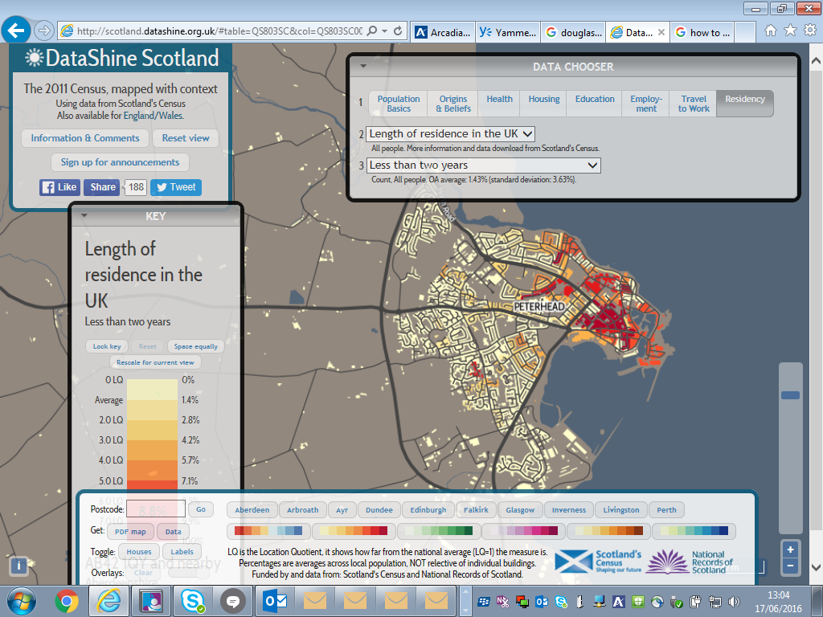

Map 2: Household tenure – owned – higher percentages of owned tenure in red, low percentages in yellow / light.
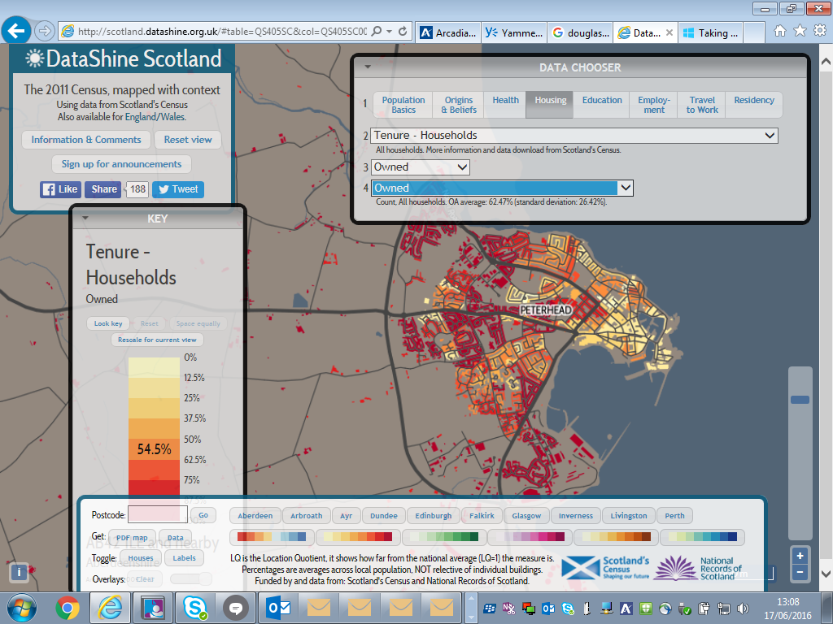

Map 3: Health – Very good health – those who report very good health – low percentages in red – high percentages of people reporting very good health in blue.

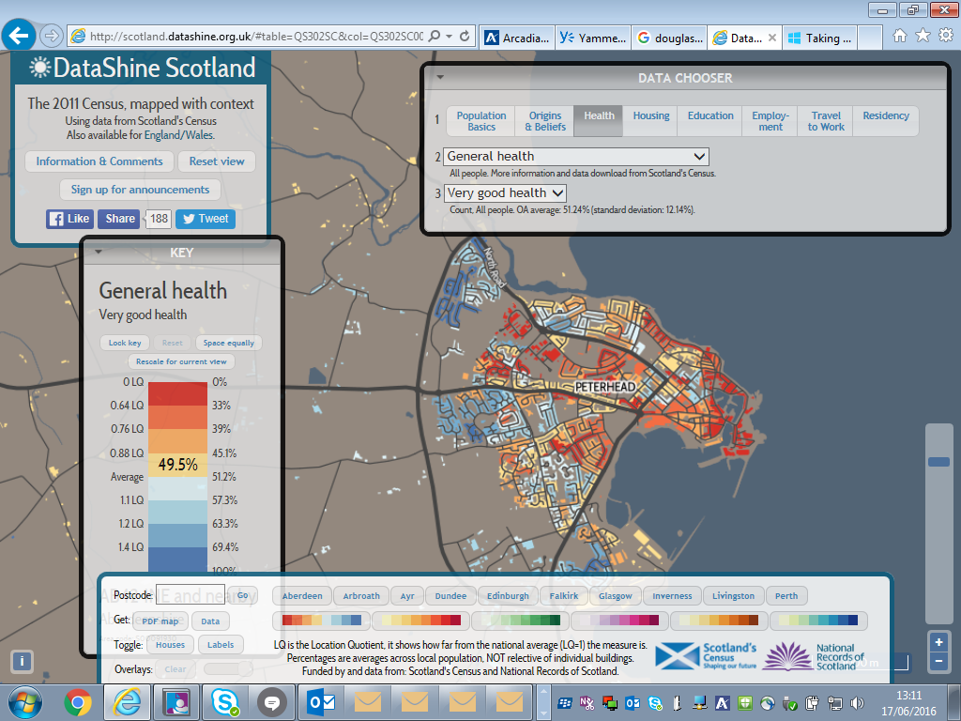
Map 4 – Commuting patterns – inflows in blue, outflows in red.
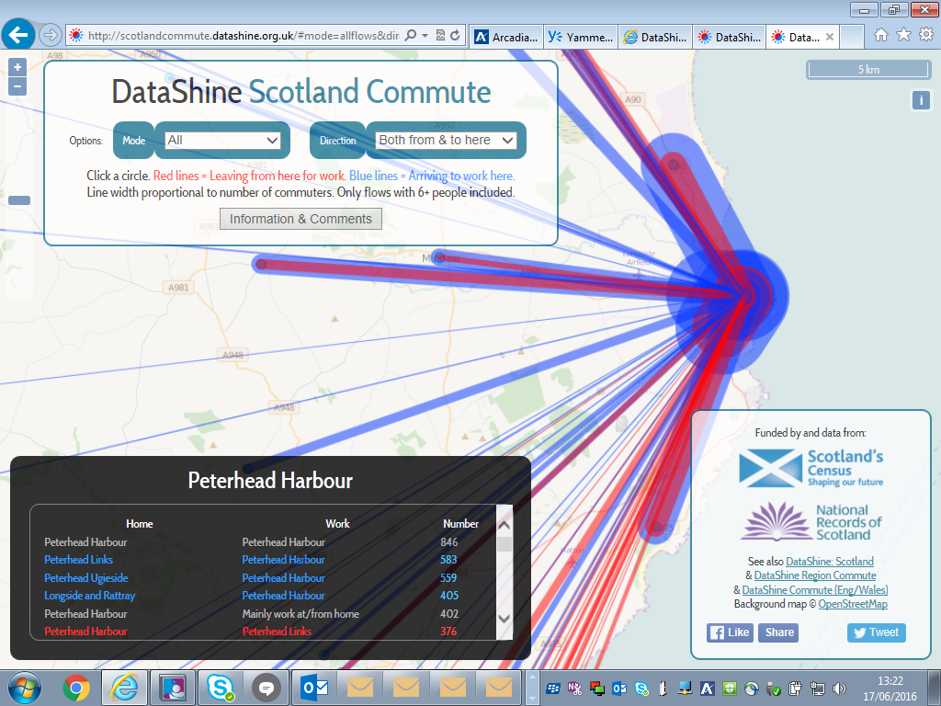

Educational Attainment:

 | S4: % of pupils with 5+ awards at SCQF level 3 |  | S4: % of pupils with 5+ awards at SCQF level 5 |  | S5: % of pupils with 3+ awards at SCQF level 6 |  | S5: % of pupils with 5+ awards at SCQF level 6
 | 2014 | 2015 | 2014 | 2015 | 2014 | 2015 | 2014 | 2015
Banff Academy | 80.6% | 81.6% | 29.2% | 35.8% | 26.4% | 22.2% | 9.3% | 6.9%
Fraserburgh Academy | 58.3% | 63.6% | 26.1% | 33.6% | 26.1% | 22.5% | 9.4% | 8.0%
Peterhead Academy | 80.5% | 84.1% | 24.5% | 29.3% | 13.5% | 21.8% | 5.5% | 9.7%
Aberdeenshire | 87.3% | 85.4% | 44.1% | 45.5% | 33.2% | 38.0% | 15.8% | 17.5%
Source:Insight

Socio Economic:
- Ageing population – falling in with national average – more older people than children. Aberdeenshire comparison, slightly more teenagers and early twenties (7% compared to 5% - post school destinations?)
- Approximately 1/5 of children across Banff & Buchan are estimated to be in poverty after housing costs – 38.3% of single parent families were out of work. Specific issues in Troup ward.
- Double Aberdeenshire average of teenage parents in Peterhead South and Cruden
- Child poverty issues although no consistent measure on effects.
- 1200 people currently on housing waiting list.
- Significant housing developments. Lower house prices than Aberdeenshire, rental increases, specifically for 4 bed houses…
- 1/5 households have no access to personal travel in Buchan
- Fuel poverty – Buchan has second highest levels of fuel poverty in Aberdeenshire behind Banff and Buchan..
- Fear of crime (town centre)
- Expectations of public sector / communities of interest stronger than community of place
- Paricipation in democracy improving
- Civic pride in Peterhead?

.

