Statutory Consultation with the Local Community under Part 8 of the Community Empowerment (Scotland) Act 2015 for Disposal of Common Good Land – For lease of area of building and area of ground at The Vinery, Airlie Gardens, Banff

Consultation dates: commences 30th March 2021 closes 25th May 2021

What land is being consulted on?
The building and area of ground (collectively referred to in this Consultation document as “the property”) at Airlie Gardens, Banff and which is shown outlined in red on the following plan:
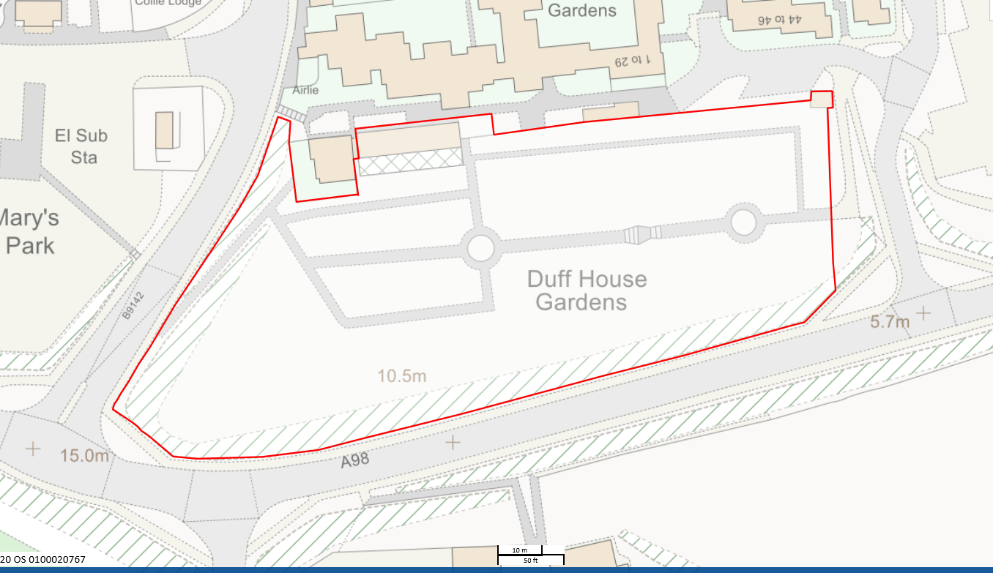

What is being proposed?
That Aberdeenshire Council should lease the property to Aberdeen Foyer for an initial period of 25 years with the principal condition of lease being that Aberdeen Foyer will use the property for furtherance of a community gardening project. Full public access will be retained to the garden grounds.

Why are we consulting?
A wide-ranging consultation exercise concerning the project was undertaken in 2018 and 2019. The purpose of the consultation was to identify the best use for this historic asset.
In June 2018, the Banff Development Partnership, which consists of elected members and business and community representatives, agreed to support the development of the project. At that stage an appraisal had been carried out on the property, but a use was not prescribed. The wider community were then enlisted to identify the preferred option for the development of the site. Public consultation was held during October 2018 to seek views on potential uses for the building.
This process was broken into two stages: Stage one provided opportunities for the community to suggest ideas for the use of the site; Stage two identified the top five suggestions that met the required outcomes for the project and took these back out into the community for a vote on the final use. Both stages involved a mixture of online and face-to-face engagement techniques and were promoted via local newspapers and social media. An online survey was published and shared for each stage via Facebook, reaching 11,397 people. Flyers were distributed to busy community locations. The surveys were shared with local organisations to pass onto their members. This was supplemented by on the ground engagement with visits to schools, sports and community facilities, supermarkets, Banff High Street, Job Club and Airlie Gardens Sheltered Accommodation. At stage one, 181 people submitted their ideas for the site. From this the most popular suggestions were tea room/café/restaurant, community kitchen and café, community garden and horticulture skill base, art/creative industry space and employability skills development. At stage two, 291 people ranked the options in order of preference. The most popular option was community garden and horticulture skill base and the project has proceeded on this basis.
Once the final use was known, an information event was held for local groups to attend to find out more about the project and the plans. Attendees agreed that they would like to form a Community Reference Group with representatives from a wide variety of local groups and interests to help ensure that GrowBanff@TheVinery is reflective of local needs. The group have met regularly to visit the site, contribute to the operator selection process and to plan a community event.
Following an open call for an operator to run the space going out in June 2019, Scotland’s Association for Mental Health (SAMH) were identified as the preferred operator in September 2019 with that being agreed to by the Banff and Buchan Area Committee on 1st October 2019. Of particular note was SAMH’s approach to understanding and responding to local needs whilst being able to draw upon their national resources and experience in an innovative and enterprising way.
A Community Open Day took place in the grounds of Airlie Gardens on 26th October, with SAMH and the architects in attendance to further engage with the wider community, share the ideas and plans and gather feedback and suggestions.
However, due to the impact of coronavirus, SAMH were unable to proceed with the project at that time and following a further selection process Aberdeen Foyer were subsequently chosen as the preferred operator. A meeting was held with local community representatives on 27th January,2021 to outline the proposed changes and the group were very supportive of Aberdeen Foyer as the new operator. Aberdeen Foyer’s designation as preferred operator was subsequently approved by the Banff and Buchan Area Committee on 9th March 2021.
Of note, is Aberdeen Foyer’s understanding of the local area and the support they provide for people in North East Scotland towards independent living, learning and work. Working with over 1600 people each year they identify people’s strengths, supporting them to build confidence, develop talents and make real and lasting change in their lives.

Aberdeen Foyer’s proposal for the use of The Vinery uses their experience to create therapeutic, training and accredited learning opportunities for community members. It will also offer an opportunity to create a positive space to showcase local talent and generate a sense of hope and pride in the local community. This project will include a kitchen garden, a kitchen, a cafe style eating area and training delivery space. Working in partnership with NESCOL (North East Scotland College) they will provide a wide range of accredited learning opportunities in-house. The project will also provide opportunities for community members of all ages to access arts, crafts and wellbeing sessions drawing on the talents of local tutors. Additionally, it will provide a safe, flexible, shared space for other community and third sector groups to use, ensuring that the Vinery can accommodate a wide variety of functions without limiting it to a single purpose. All activities will also be linked to employability, training, skills development and improving wellbeing.
As the project progresses, Aberdeen Foyer are keen to put the local community at the heart of the project and will continue to work with the Reference Group and other local stakeholders to achieve this.
While the work previously undertaken has established that the project enjoyed considerable public support it is also the case that the present consultation requires to be undertaken on account of the fact that the property is part of common good land which is owned by the Council with the property forming part of a greater area of land which was gifted by the Duke of Fife to the Burgh Councils of Banff and Macduff in 1907.When considering disposal of certain types of common good land (whether by sale or lease), certain legal requirements must be followed. These are:
- Carry out a statutory consultation with the local community under Part 8 of the Community Empowerment (Scotland) Act 2015; and
- If required, seek approval from the Court under s.75 of the Local Government (Scotland) Act 1973.
This consultation is being carried out to satisfy the first legal requirement and further guidance on the process can be found here.
https://www.gov.scot/publications/community-empowerment-common-good-property-guidance-local-authorities/
Court approval will be sought if the Council decides to proceed with the disposal following the Consultation.

What are the benefits of the proposal?
GrowBanff@The Vinery meets a need for social regeneration and inclusive growth identified as part of an overall regeneration programme in the Banff and Macduff area. It will bring new life to a building which has been vacant for many years. It also responds to issues highlighted by the coronavirus pandemic recognising the importance of good quality local greenspace, the power of gardening for mental wellbeing and access to opportunities for training and social interaction.

GrowBanff: People The project offers transformational opportunities for the people of the area who participate in the wellbeing activities that the Vinery refurbishment will enable to take place. The project and therefore the benefits of participation will be accessible to all. One in four people will experience a mental health problem each year, and with a population of 8050 in the immediate locality, that is just over 2000 people.
Through the appointment of Aberdeen Foyer as the operator for the building, individuals will be able to benefit from the therapeutic powers of gardening to help people regain confidence, develop new skills in horticulture and cooking or accessing qualifications, build self-esteem and motivation as well as creating new social networks. These interventions have the power to change lives. The ability to make connections with others through a collective aim of gardening and growing will particularly benefit those who are most isolated in our communities, such as the long-term unemployed, economically inactive, and people who have mental health support needs.
GrowBanff: Place The Vinery is prominently situated within the community. It is a gateway site to the town centre, within the Conservation Area, and links key areas such as Duff House to the retail centre of Banff. It is highly visible, being located next to the A98 and a part of the NE250: as first impressions count its current condition reflects poorly on the town. A recent Locality Planning exercise that was conducted in Banff identified (through the Place Standard Toolkit) that 75% of people felt that the condition and deterioration of buildings was a negative characteristic. The same exercise demonstrated a demand for drop-in community facilities specifically relating to mental health. Following its restoration, the site will draw in passers-by and encourage footfall through the town. The deterioration of the Vinery buildings over several years has been felt by residents. It has been part of a pattern of decline of the built environment that the Banff Vision and Action Plan hopes to address through the redevelopment of key sites. This investment will lead to the transformation of this part of the townscape, new local economic activity and increased community pride.
GrowBanff: Economy The project will be a highly visible demonstration of how enterprise and social activities can be merged for the benefit of the town. The proposed model of activity will utilise the unique assets of the site for growing and producing plants, fruits and/or vegetables to sell in both their natural form and also after processing into, for example, soaps, oils, preserves etc. This will generate new products that can be branded as ‘Banff’ and will provide an additional attraction to the town. This ties in with a wider remit within the Banff Action Plan to develop new food and drink opportunities in the area.
GrowBanff: Environment The Vinery sits within Airlie Gardens, which is a remnant of former more extensive Duff House policies. The south-facing garden is enclosed by a wall and road embankment and offers a great space for leisure and growing activity. The gardens however, are currently under-used, although public consultation suggest that they are highly valued. Through the future use of the Vinery as a space for horticulture, it is planned that volunteers and local groups will be able to work in the gardens and make them once again an inviting place for people to visit. The project also offers the opportunity to promote sustainability through local food production on site, encouraging more people to think about the impact of their purchasing patterns.
This proposal will therefore have the following positive outcomes for the Banff and Macduff communities:
- Reduced barriers to employment and poverty by providing training, work experience and building confidence for local people.
- Improved health and wellbeing by developing new opportunities linked to the local environment.
- Improved quality of place through the restoration and reuse of a B listed former Vinery building and its associated historic gardens.
- Improved social capital by bridging the generation gap and building a greater sense of community pride in a key site in Banff.
- Boost the economy by growing and developing products that can attract tourists and local shoppers alike.

Are there any drawbacks to this proposal?
Work to complete the restoration could involve disruption to neighbouring properties. However, discussions have been ongoing with the two sites most affected by the project to ensure that residents are aware of the project, its scope and timescales. There will also be temporary disruption to the garden grounds for access and health and safety purposes as the construction is undertaken, although public access will be maintained throughout.

Please answer the following question:
Do you agree that Aberdeenshire Council should lease the property to Aberdeen Foyer for an initial period of 25 years for furtherance of a community gardening project.
Please circle or underline your answer: Yes / No
Please provide any additional comments
Comments:

Contact details:
Name of Organisation or Individual
Address

Postcode

Email

What happens next?
Aberdeenshire Council will consider and respond to any representations within eight weeks of the consultation closing date. The Council’s final response will be published on the Aberdeenshire Council website (www.aberdeenshire.gov.uk/council-and-democracy/community-empowerment/) along with details of all representations to this consultation (excluding address, postcode and email of respondent).
The Council will then take a decision having regard to the outcomes of this Consultation as to whether to proceed with the disposal.
Completed forms can be returned preferably via email to: suzanne.rhind@aberdeenshire.gov.uk and copied to: james.mckay@aberdeenshire.gov.uk or via post to: ‘The Vinery Public Consultation Response’, Area Manager’s Office, Town House, Low Street, Banff, AB45 1AY.
Please return forms by 25th May 2021.

