

Local PERCENT FOR ART form

This form is for communities to request the allocation of their community percent for art funds for a public art project in their settlement

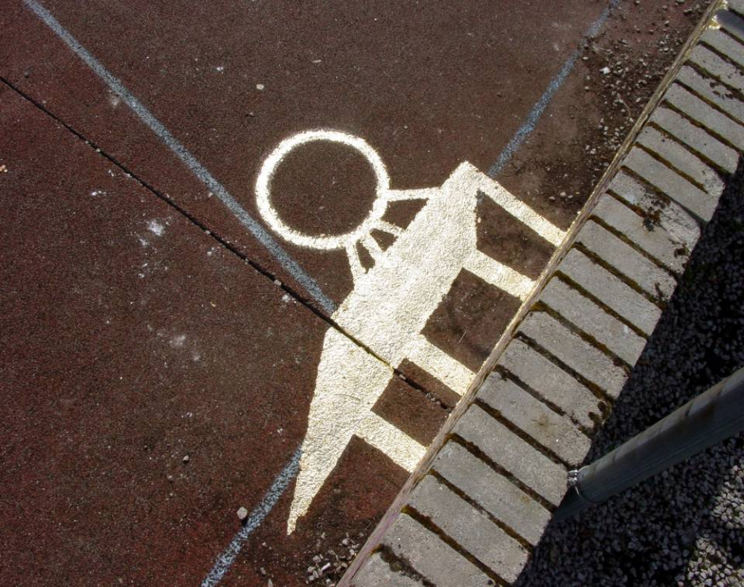
Westhill H’Art by Ginny Hutchison

Definition of the term public art:
- Public art should be original work reflecting an area, created by an artist or craftsperson.

- The term public art encompasses a wide range of artistic practice and ways of working. The defining factor is that public art should be in the public domain, accessible or visible to the public and designed/produced by an artist or maker.

- It should not be a mass produced object or a reproduction of an original artwork as these are unlikely to be site specific to the area. When public art follows best practice the community is involved in the journey and the decision making process about the space or event.

- Community art can be confused with public art as it often follows similar consultation styles: one difference comes with any end product. Public art is designed and delivered by the artist in consultation with the community, whereas an artist facilitates a community art project but the end product is co-designed by the whole group and has group authorship.
.

Developer Obligation funds for the arts:

If you are developing a project which could be funded, we would want to see how it relates to the people of the town. There needs to be evidence that there is a demand for your proposal from the local community which can be achieved through a programme of public engagement. There is a checklist which can help groups when working on a public art project available from the Public Art Officer.

Please use the attached form to outline your proposal and forward to the Public Art Officer. Your idea will then be submitted to the Cultural Services Senior Management Team for discussion and consideration.

Public Art Proposal

The main criteria for public art are that the resultant work concerns a place and is delivered and designed by an artist. Please note that it does not have to be a permanent structure.

Date of Application

Name of Group or Organisation

Address
Name & Position of lead contact

Telephone and email of main contact

Name of project:

Place or site which is the focal part of the project:

Who in your community, including local councillors, have you informed about this project:

What is the main practice of the professional artist/s you propose to involve in the project:

Description of the project or vision for the place/site: (Write out the project’s basic proposal)

Continue on a separate sheet if needed

Project management 1:
Who will fill the following roles and their experience – there needs to be at least two people to fill these three roles.

Overall Project manager | Name:  Experience:
Community and public involvement manager | Name:  Experience:
Event manager - the person who organises the installation of the piece or the event if it is a festival | Name:  Experience:

Project management 2
Describe how you will deliver the project.

Add as much information as you feel relevant but please include:

- a project timeline
- a budgeted break down of all costs
- how you propose to employ your artist/s and who will be the commissioner
- landowners or event site owners permission
- evidence of considering planning permission within your timeline where necessary (permanent structure)
- decommissioning programme for temporary work
- how you will ensure the work is maintained (if a permanent structure is proposed)

Once complete, send with a copy of your group’s constitution / rules to:

Saskia Gibbon
Arts Development Officer & Public Art Officer
saskia.gibbon@aberdeenshire.gov.uk

For Office Use Only:

Comments:

Date:
Author:

