**Banff and Buchan**

**Area Committee Budget**

**2025/2026**

**SECOND TRANCHE**

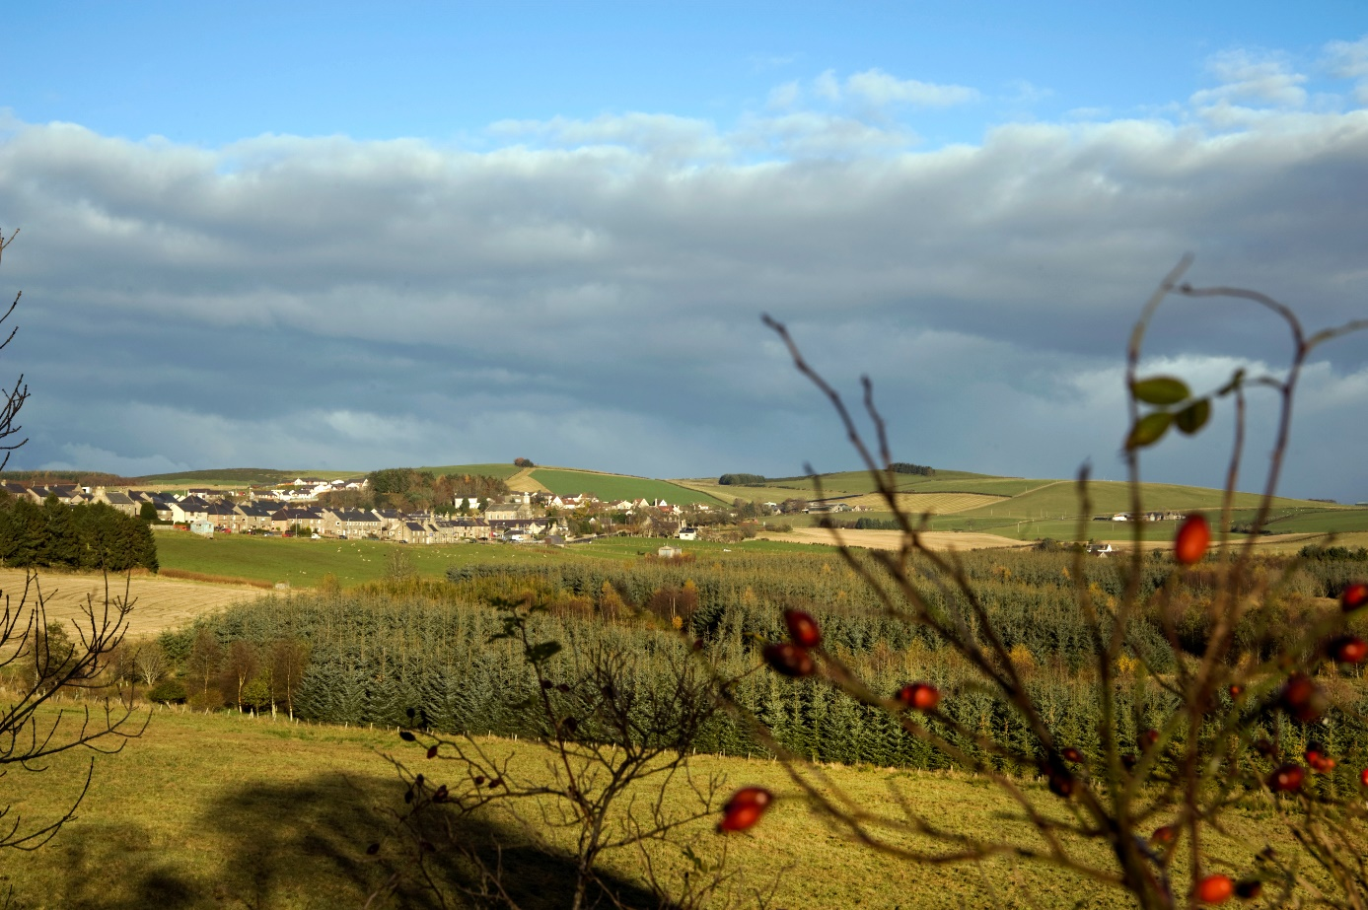

**Funding Application Form**

The Banff and Buchan Area Committee Budget is to be used responsively to address the needs of communities and maximise scarce resources. It also promotes, through the utilisation of all available resources, opportunities to work more closely with individuals and communities to understand their needs, maximise talents and resources, support self-reliance and build resilience.

The budget will contribute 100% of the first £1,000 with 80% of the remaining project cost up to £5,000. All money awarded must be spent within the Banff and Buchan Area.

**1. Contact Details - Please provide details below.**

|  |  |
| --- | --- |
| **Name of Organisation/Group** |  |
| **Contact Name** |  |
| **Position** |  |
| **Address (including postcode)** |  |
| **Telephone Number(s)** |  |
| **Email Address** |  |
| **Please enter the Treasurer and Bank Account details below** | |
| **Name of Treasurer** |  |
| **Address (including postcode)** |  |
| **Telephone Number** |  |
| **Email address** |  |
| **Group/Organisation’s Bank Details** | **Name of Bank:**  **Sort Code:**  **Account No.:** |

**2. Themes - Please indicate to which of the following themes your project relates. There may be more than one so please tick all that apply.**

|  |  |
| --- | --- |
| **Theme** |  |
| Improving the appearance and maintenance of towns and villages within Banff and Buchan | ☐ |
| Stronger communities | ☐ |
| Safer communities | ☐ |
| Supporting health and active communities | ☐ |
| Tackling poverty and inequalities | ☐ |
| Transport and connectivity | ☐ |

**3. Projects must align to at least one of Aberdeenshire Council Priorities. Tick the Council Priorities your project helps to deliver. There may be more than one so please tick all that apply.**

**Council Priorities**:

|  |  |  |
| --- | --- | --- |
| **Connected communities:**  The project will work with communities and partners to enhance the sense of connection among places. This includes supporting communities to come up with innovative solutions to ensure our places are resilient and vibrant. | Support communities to articulate the challenges facing them and how we can achieve better outcomes together | ☐ |
| Improve digital connectivity by securing investment for better infrastructure for homes and businesses | ☐ |
| Collaborate with partners and communities to attract investment to enhance travel and transport connections between our towns and villages | ☐ |
| Encourage and promote active travel – supporting healthier, more sustainable and environmentally friendly travel options | ☐ |

|  |  |  |
| --- | --- | --- |
| **Living well locally:**  The project will encourage and support residents to lead healthy and active lives, to contribute meaningfully to their communities and will be reflective of the needs of the ageing population. | Promote greater participation by communities, so we are working to shared and collective ambitions in our places | ☐ |
| Facilitate the provision of affordable housing | ☐ |
| Help people to lead independent lives through prevention and early intervention, providing care and support to those most in need | ☐ |
| Work with and support opportunities for residents to be healthy and active | ☐ |
| Ensure children and young people have a greater say in matters that will affect them now and, in the future | ☐ |
| Improve the life chances of people at risk of falling into poverty, or already living in poverty | ☐ |
| **A sustainable economy:**  The project will support a strong and diverse economy by attracting people of working age to the region, complementing the highly skilled local workforce. | Contribute to the creation of a skilled and resilient workforce by developing skills children and young people need for learning, life and work now and in the future | ☐ |
| Equip residents to meet the key challenges and transition ins their lives through lifelong learning | ☐ |
| Support new and existing businesses to thrive and provide for work opportunities | ☐ |
| Secure inward investment to sustain economic growth | ☐ |
| Attract and retain people of working age to the region | ☐ |

**4. Select which of the** **Place and Wellbeing Outcomes apply to your project (tick those that apply):**

|  |  |
| --- | --- |
| **Stewardship** (care and maintenance, influence and control) | ☐ |
| **Movement** (public transport, active travel, traffic and parking) | ☐ |
| **Civic** (identity and belonging, feeling safe) | ☐ |
| **Spaces** (streets and spaces, natural spaces, play and recreation) | ☐ |
| **Resources** (services and support, work and economy, housing and community) | ☐ |

**5. Description of Project - Please provide a description of your proposed project including aims, objectives and outcomes.**

|  |
| --- |
| **Description** |
|  |

**6. Project Plan - Please provide details of the plan for your project.**

|  |  |
| --- | --- |
| **Project Plan** | |
| **Name of person managing project** |  |
| **Contact email (if person managing the project is different from section 1)** |  |
| **Telephone number (if the person managing the project is different at section 1)** |  |
| **When will the project start?** |  |
| **When will the project finish?** |  |
| **What are the key milestones in the project?** | |

|  |
| --- |
| **What are the key risks in the project?** |

**7. Community Support - Has the project been identified and prioritised by the community? (For example, through a Community Action Plan exercise and/or other consultation events)? If so, please provide details below.**

|  |
| --- |
| **Community Support** |
|  |

**8. Maintenance Arrangements - Please confirm that your project will not require any future maintenance by the Council in terms of either a financial or time cost. Please identify who will be responsible for any future maintenance.**

|  |
| --- |
|  |

**9. Project Cost - Please provide details of the expected cost of your project.**

|  |  |
| --- | --- |
| **Total cost of project including VAT where applicable** |  |
| **Amount requested** (the budget will contribute 100% of the first £1,000 and 80% of the remaining costs up to £5,000) |  |
| **Breakdown of cost (if appropriate)**  **Please provide a quotation for any goods or work.** |  |

**10. Previous Awards - Have you had funding from the Area Initiatives Fund in the last three years? If so, please state the project and the amount received.**

|  |  |  |
| --- | --- | --- |
| **Project** | **Amount Awarded** | **Year** |
|  |  |  |
|  |  |  |
|  |  |  |

**11. Other Funding Applied For - Have you applied for any other funding in relation to this project? Please give details below.**

|  |  |
| --- | --- |
| **Who have you applied to?** | **How much was awarded?** |
|  |  |
|  |  |
|  |  |

**12. Organisation Finance - Please provide details of your current bank balance. If any of the balance has been ring-fenced for other projects, please provide detailed information. All information received may be considered in the decision-making process.**

|  |  |
| --- | --- |
| **Current Bank Balance** |  |
| **Ring-fenced money (Please provide detailed information on any of the money that has been ringfenced for other projects and therefore cannot be used towards this project)** |  |

**The person signing this form will be responsible for ensuring that the money awarded is used for the purpose stated in the original application and that receipts are sent to the Area Manager’s office before 16 March 2026.**

|  |  |
| --- | --- |
| **Name** |  |
| **Position** |  |
| **Date** |  |

The closing date for completed applications is **5.00pm on Monday, 18 August 2025. Please return the completed application form and any supporting documents to**:

**Email:** [**banffandbuchanamo@aberdeenshire.gov.uk**](mailto:banffandbuchanamo@aberdeenshire.gov.uk)

**If you have any questions, please Telephone: 01467 530700**

All valid applications will be considered at Banff and Buchan Area Committee on Tuesday, 9 September 2025.

**Please check that you have included the following documents:**

|  |  |
| --- | --- |
| The application form |  |
| Copy of quotations of proposed works or goods |  |
| A copy of the group’s Constitution, or Memorandum and Articles and any affiliations. |  |
| A copy of groups insurance and where appropriate certification e.g. PVG check |  |
| A copy of the most recent independently examined accounts |  |
| Three Most recent bank statements |  |

**Groups must be able to give an assurance that they will be able to complete their projects and have receipts submitted by 16 March 2026 and will be expected to provide regular feedback on progress, to the Area Manager’s Office, when requested.**

Once the project is complete, successful applicants will be requested to provide a short report so that the Area Committee can have an indication of how the money has been spent and how the project has benefited the community.

**Privacy Notice**

The Data Controller of the information being collected is Aberdeenshire Council.

The Data Protection Officer can be contacted at Town House, 34 Low Street, Banff, AB45 1AY. Email: [dataprotection@aberdeenshire.gov.uk](mailto:dataprotection@aberdeenshire.gov.uk)

Your information is being collected to allow Aberdeenshire Council to make payments to you.

The Legal Basis for collecting the information is:

|  |  |
| --- | --- |
| **Personal Data** | |
| Task carried out in the Public Interest | X |

Your information will be shared with the following recipients or categories of recipient:

Aberdeenshire Council Senior Management Team, Members of the Area Manager’s Office, Legal and Finance Services, Community Planning Partners and Aberdeenshire Councillors. Details from your application may also be made public through our corporate communications team.

Your information will be transferred to or stored in the following countries and the following safeguards are in place:

*Not applicable*

The retention period for the data is:

7 Years

The following automated decision-making, including profiling, will be undertaken:

*Not applicable*

Please note that you have the following rights:

* to lodge a complaint with the Information Commissioner’s Office (after raising the issue with the Data Protection Officer first);
* to request access to your personal data;
* to request rectification or erasure of your personal data, as so far as the legislation permits.